South East Technological University,

Waterford



Semester 1: Project Analysis and Design

Promotional Tool-Kit for a Musician

_________________________________________

Author: Supervisor:

Jake Dunphy O’Leary Brenda O’Neill

Student Number: 20101923

Course: BSC. In Creative Computing

Monday, December 8, 2025



“Nothing really matters, but it matters if it matters to you”

Carly Rae Jepsen, Kollage. (Jepsen, C.R., 2023)

South East Technological University, Waterford

Abstract
The paper provides information, instructions, and examples of a promotional tool-kit for an independent musician to use for their own releases. The paper looks at digital design programs, methodologies for each potential aspect of creation, what physical and digital media can be created for promotion, and an example schedule for the reader to follow.

School of Science and Computing

Department of Computing and Mathematics

Course: BSc. In Creative Computing

4th year project Semester 1

Promotional Tool-kit for a Musician

By

Jake Dunphy O’Leary

Declaration of Authorship

I, Jake Dunphy O’Leary, declare that this report titled, “Promotional Tool-Kit for a Musician” and the work presented in it are my own. I confirm that:

This work was done wholly or mainly while in candidature for an undergraduate degree at this University.

Where any part of this report has previously been submitted for a degree or any other qualification at this University or any other institution, this has been clearly stated.

Where I have quoted from the work of others, the source is always given. With the exception of such quotations, this report is entirely my own work.

I have acknowledged all main sources of help.

Where the report is based on work done by myself jointly with others, I have made clear exactly what was done by others and what I have contributed myself.

If AI was used, I have made clear why and how AI was used.

Signed:

------------------------------------------------------------------------------------------

Date:
---------------------------------------------------------------------------------------------

Table of Figures
Figure 1: Mapping activity to software use 9
Figure 2: Adobe Product Logos (Proprietary and industry standard) 11
Figure 3 - Graphic Design Methodology (Kirpichnikov, 2025) 15
Figure 4 - 3D Modelling Methodology Diagram 1
Figure 5 - Video Production Pipeline Diagram [vmdigital, 2021] 2
Figure 6 - Jewel CD Case [Ramón Vasconcellos, 2007] 3
Figure 7 - Pink Tape by f(x) Album Box [Koreaboo, 2017] 3
Figure 8 - Filament by Pragun Agarwal [Pragunagarwal.com, 2025] 4
Figure 9 - Music T-Shirt Example [tasty design, 2025] 4
Figure 10 - Aespa Supernova Poster [Grupo Erik Editores S.L., 2025] 5
Figure 11 - NMIXX Promotional Video Example [JYP Entertainment, 2025] 5
Figure 12 - LE SSERAFIM Visualiser Video Example [HYBE, 2025] 6
Figure 13 - Production Timeline example 7

Table of Tables
Table 1 Program Table 2
Table 2 User Stories 3
Table 3 Laptop specification (low budget) 7
Table 4 Desktop Specifications: (Higher Budget) 7

Acknowledgements

Brenda O’Neill – Lecturer at SETU and Supervisor of Project.

Table of Contents
Abstract III
Declaration of Authorship IV
Table of Figures VI
Table of Tables VII
Acknowledgements VIII
Chapter 1: Introduction 1
Chapter 2: Project 2
Description 2
Inspiration 3
Scope 3
Target Audience 3
User Stories 3
Chapter 3: Feasibility 4
Market 4
Commercial 4
Unique Selling Points 5
Technical Feasibility 5
Risk Assessment 6
Backups 6
Budget 6
Copyright 6
Chapter 4: Technologies 7
Hardware 7
Software 8
Open Source: 9
Proprietary/Industry Standard: 10
Proprietary (Free): 11
Chapter 5: Methodology 13
Choice of Methodology 13
Graphic Design 13
3D Modelling & Rendering 15
Conceptualisation and Planning 15
Blockout 15
Modelling the Basic Shape 16
UV Mapping 16
Texturing 16
Rendering 16
Video Production & Rendering 1
Pre-Planning 1
Pre-Production 1
Production 1
Post-Production 2
Chapter 6: Design 2
Album Box Design 2
CD Design 3
T-Shirt Design 4
Poster Design 4
Promotional Video 5
Visualiser Video 5
Chapter 7: Planning Schedule 6
Design and Development Schedule 6
Tracking Progress 7
Conclusion: 7
References 9
(Alphabetical order) 9
Appendices 12

Chapter 1: Introduction
Design software, much like anything else in the world, comes in many different forms and styles. Often times, people flock to the most popular or well-regarded software for their needs, but this does not always mean they are the best option. In a world of ever-advancing technology, it is more important than ever to consider all options, and analyse what makes a software “industry standard”. Doing so may help in seeing why the trendy software is as popular as it is, or it may be found that the software does not gel.
This project exists both as a baseline and as a demonstration. It shows creatives that, while the first hurdle may be the most daunting, it is certainly not impossible to cross. Whether constraints are because of low/no budget, lack of powerful hardware, or simply a lack of technical knowledge, there are options for software to suit diverse needs.
The goal for this project is that it can be used as an example for those wishing to start in digital creation, either as a hobby or even as a potential career option.
The following chapter of this document will give an overview of the project itself

Chapter 2: Project

Description
This project entails the creation of various promotional materials for a musician to use to promote his/her musical projects. It includes:
- Album box art (front, back and sides)
- A digital cover for streaming services
- An artist logo and banner (for use on social media and streaming sites)
- A CD design
- A promotional poster
- A track list poster
- Merchandise designs (t-shirts, hoodies, stickers, etc.)
The following software that this project investigates are:
Table 1 Program Table
Activity | Industry Standard Software | Proprietary Software | Open Source Software
Photo Editing | Photoshop | Affinity Photo | GIMP
Vector Graphics | Illustrator | Affinity Designer | Inkscape
3D Modelling/Rendering | Maya | ZBrush | Blender
Video Editing | Premiere Pro | Magix Vegas | Kdenlive
Digital Motion Graphics | After Effects | DaVinci Resolve | Friction

Inspiration
The inspiration for this project comes from various musicians and the different design languages they use to express their craft. Visual design has an inherent relationship with music and this project aims to show and detail that connection and make it easier for the musician to develop their own design language for their music projects.

Scope
The scope is to utilise design software that covers different segments of digital creation (Video Editing, Photo Editing, Vector Graphics), sorted by release types (Industry Standard/ Proprietary/Open Source). These programs will then be used to create, design and promote material for a music album and relevant materials (merchandise, posters). The process of creating these materials will be comprehensively documented using the various types of software. The experience and knowledge gained whilst using them will culminate in a practical and comprehensive user manual.

Target Audience
Creative people often struggle when it comes to making sleek and professional digital materials. This project aims to give a baseline for creatives to work with. By the end of this project and report, a creative person will understand and know how to make start in digital creation. They will be able to use digital technology to create music and promote their work.

User Stories

Table 2 User Stories
User Story | Acceptance Criteria
As a musician, I want an easy way to dip my toes into digital creation so I can make promotional materials for my music. | Given that I have little to no experience in digital creation, when I read and follow this research document, then I have a good starting place and knowledge to work with.
As a creative with a smaller budget, I want examples of high-quality software and hardware to use that is within my budget so I can still practice creativity without breaking the bank. | Given that I have a lower budget to work with, when I want creative software to work with, then I should be able to use the open source/free software detailed in this document.
As a creative using Linux distributions, I want open-source software to use so I am certain it supports my Operating system. | Given that I prioritise Linux, when I read this document and use the software listed, then I should not have to compromise and switch to Windows or MacOS.
These user stories tie into the next chapter of this document, where the feasibility of the project is analysed.

Chapter 3: Feasibility

Market
Music is a vast and varied market that is difficult to break into as an independent creative. It is not impossible, however. Promotion is half the battle when it comes to being a musician, and this document gives a comprehensive outline for an independent musician to create their own promotional materials for their music.

Commercial
Being an independent musician inherently comes with more freedom than being a signed musician. This can allow musicians to be experimental and bold with their releases. This comes at the cost of a struggle to “make it big” commercially. With the advent of social media algorithms, fame and success are more unpredictable than ever. This makes sustaining an audience difficult, but it also makes it easier than ever for an independent artist to attract attention.
This document covers much of how a musician may choose to promote themselves. A musician who wants to present as professional and skilled could use the commercial and industry standard programs and methodologies outlined, while a musician simply looking to express their true selves and hone their craft can use the open-source alternatives.
Creativity has endless approaches, and this document respects that.

Unique Selling Points
This project and subsequent documentation looks at digital creation from a person-first lens. It is important to be critical of the tools and concepts that are the current most popular, to see why they are successful, and perhaps see where they hold flaws. This document looks to give aspiring creative artists a look at the vast options that digital creation holds.
This document is also mindful of budget constraints, or a lack thereof. Creative artists with a larger budget can afford subscriptions to the products with the largest budget and developer base, while those in poorer countries or general financial situations can turn to the fellow independent creative communities that make their own software.

Technical Feasibility
This project as a whole is achievable with some minor obstacles. The first of which is that a computer is required to use all of the programs that this document details. Some programs may have alternatives for mobile devices, but most do not and even the ones that do likely lack full functionality.
While this project details free and open-source programs, there are also paid software listed here. These programs may have free trials or ways of trying them without paying, but their full functionality will be behind a paywall.
Having an interest in digital creation is important. This project does not require the reader to have a vast and detailed knowledge of design and computing, but it is recommended to make this document easier to follow. A stable internet connection is also highly recommended so the user can access educational resources and keep their programs up-to-date.

Risk Assessment
This project bears some risks that are important to keep in mind. This project is not dangerous in any way, but working with digital data can be volatile due to the inherent nature of computers and data. Three main risks are listed below.
Backups
Keeping backups of all projects and exports is extremely important. Losing the data for a project can be a massive setback, and no easy ways to recover old projects can be detrimental. Having an extra hard drive or cloud storage to make backups on regularly is essential.

Budget
This project also comes with a potential major budgetary risk, which involves the replacement or purchasing of a new computer, if necessary. Computers can break for any number of reasons, and a primary device failing while completing the project is an unlikely but completely possible risk.

Copyright
Another major risk with creative work is copyright infringement. This document and project strongly recommend the reader to research the terms and conditions of any pre-made assets used, and to understand the conditions set out by the creators of the programs that this document discusses. This is an especially important risk to take into account when it comes to Artificial Intelligence (AI), which this document strongly discourages the incorrect use of.

Chapter 4: Technologies

Hardware
This project uses two different devices, a higher budget desktop and a lower budget office laptop.

Table 3 Laptop specification (low budget)
Laptop Specifications (Lower Budget):
Make/Model: Avita Liber V
Screen Size: 14 Inches, 1920x1080 HD Display
Ram: 8 GB DDR4
CPU: AMD Ryzen 5 3500U
GPU: Radeon Vega 8 Graphics
Storage: 250GB SSD
Operating System: Windows 10 LTSC

Table 4 Desktop Specifications: (Higher Budget)
Desktop Specifications: (Higher Budget):
Motherboard: MSI PRO H610M-E DDR4 (MS-7D48) 2.0
RAM: 16GB DDR4
CPU: Intel Core i5 12400F
GPU: NVIDIA RTX 3060 12GB
Storage: 1TB SSD
Operating System: Windows 10 LTSC

Software
The following diagram represents the activities that a creative artist engages in and the potential software for these activities. They are color coded based on the type of software for easy identification.

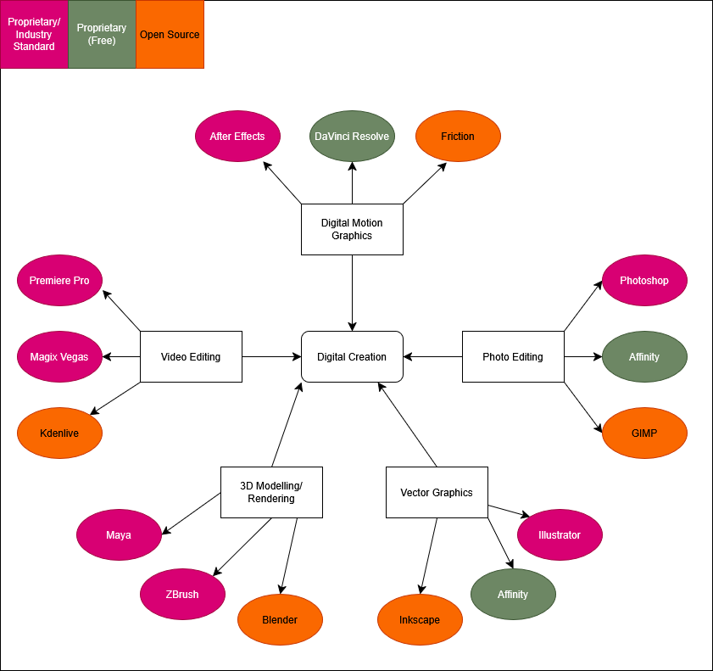
Figure 1: Mapping activity to software use
It is important to understand what open source, proprietary and free mean.

Open Source:
Open source, in relation to software, refers to software where the owner and creator allows others to freely use, inspect, and modify its source code. This encourages open collaboration and community between both users and developers. Open-source software is typically free, but this is not guaranteed. Open-source software is typically created for a multitude of reasons. This includes:
- Fulfilling an untapped niche.
- To provide a lower cost alternative to an existing proprietary program.
- For a developer to practice development with a low-stakes project.
- There are many other reasons for Open-source software to be created, but these are some of the more common origins. Not for profit.
- Open-source does not necessarily mean it is made independently or without a team structure. Two examples of project team structures are detailed by Ben Balter.
- Balter describes the Cathedral and Bazaar people management styles.
- The Cathedral style works top-down using a focused vision and goals, led by a manager. It provides clarity and a sense of stability, but can feel rigid and like a hierarchy. Poor management is felt deeply in this style.
- The Bazaar style works more broadly and without specific, detailed goals. The manager acts like a guide or a coach for the team, rather than a leader. This style promotes innovation and openness, but can lead to confusion and aimlessness if poorly managed.

Proprietary/Industry Standard:

Proprietary software is software that is only available to its creators, typically a company, that is the software’s sole developer and distributor. Proprietary software can also be described as “for profit” software, existing with the intention of selling to a large consumer base.
Proprietary software often takes less risks or experimentation compared to open-source software, and have tightly held licenses and source code that are rarely, if ever, released to the public willingly. Software is made proprietary for various reasons, such as:
- Preventing competing companies from using their source code as a baseline.
- Preventing users from freely modifying and changing code, therefore requiring reliance on the owners.
- Allowing for tightly locked license distribution, making piracy more difficult.
- Making security updates more secure due to a lack of freely available code.
Proprietary software is often developed by much bigger and more experienced teams, with a focused vision in mind. This leads proprietary software to come across more professional and solid compared to open-source software. This comes at a literal cost, as well as the cost of transparency and communal development. Typically, commercial.
A good example of commercial design products is the Adobe suite. Adobe creates and manages a large variety of design programs, some of which this document looks at in more detail.
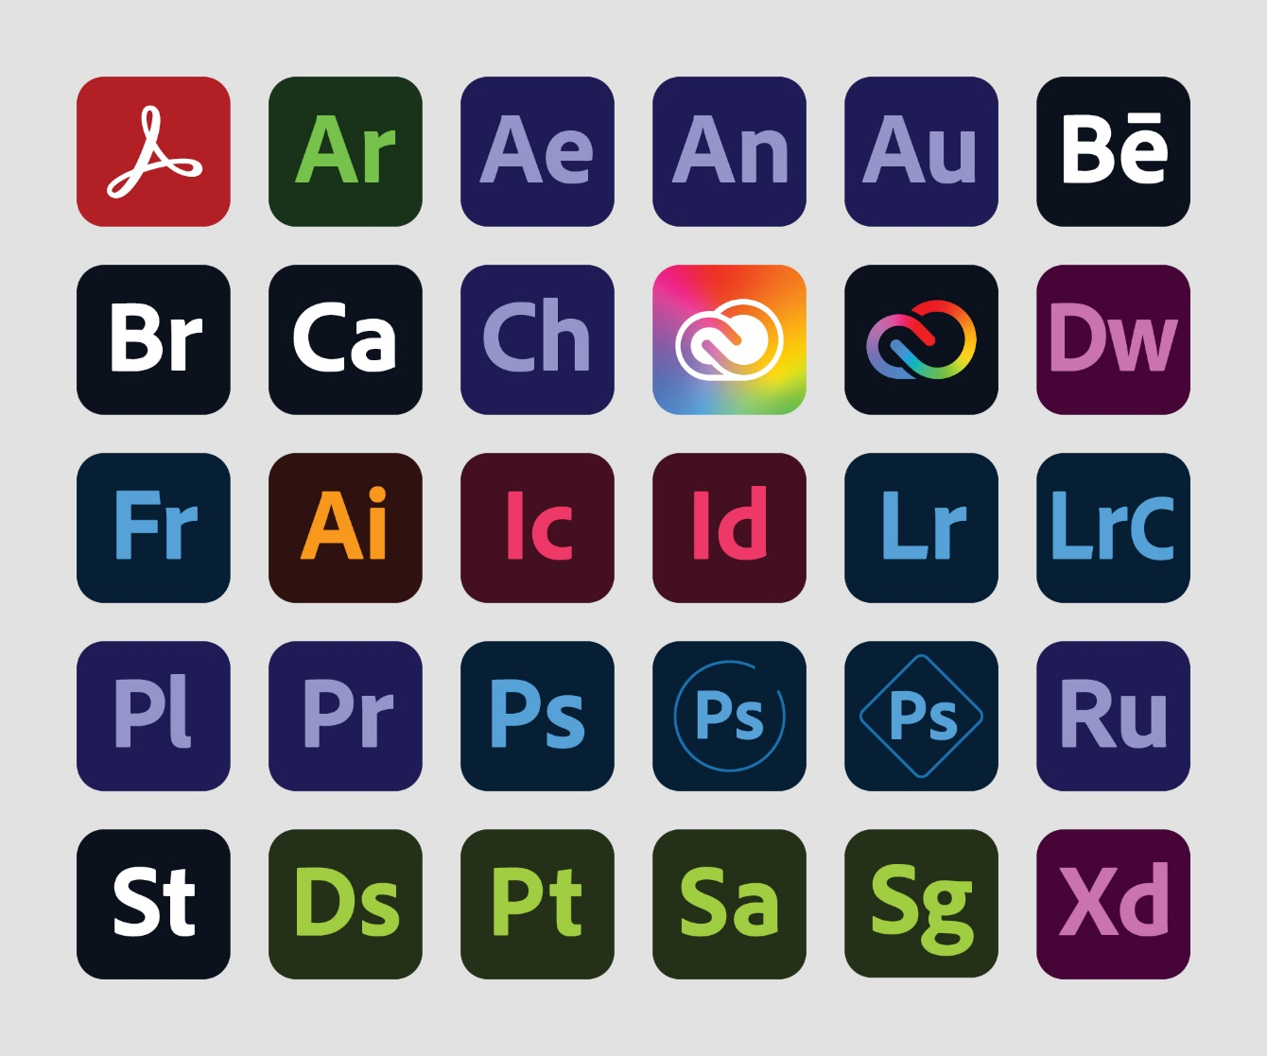
Figure 2: Adobe Product Logos (Proprietary and industry standard)

Proprietary (Free):

Some proprietary software is made free to use by its owners. This is usually done by a corporation who is not making enough profit by putting their product behind a paywall. Corporations must have some alternative way to still make a profit when their products are released for free. This often comes in the form of advertisements built into the program itself. Sometimes it is done when a corporation makes enough of a profit by other means that they can afford to release one of their products for free.
Affinity Photo and Affinity Design, originally a collection of proprietary programs owned by Canva, were combined into one free program earlier this year, whilst this document was being written. A statement from Canva themselves state that they were a stable enough company to release Affinity for free. (Hewson, 2025)

Chapter 5: Methodology

Choice of Methodology
This document does not use one singular methodology throughout, such as Agile or Waterfall. The reason for this is that design and artistic projects are not as rigid and measurable as a project such as software development. Because of this, each major creation aspect this document covers will use its own methodology, decided on through analysing the most common method used by professionals.

Graphic Design
This document lays out a 6-step process for the Graphic Design aspect. This methodology is documented by Ihor Kirpichnikov (Kirpichnikov, 2025), and Jessica Barker of Brafton (Barker, 2025). The steps are as follows:

Design Brief
This step is where the aims of the design are pre-defined. This can involve detailing a design language, what style to achieve, what formats and canvas sizes will be used, what the design is for, etc.
This step is where the basis of the project is laid out.
For example, if designing a CD Cover, you need to consider how large a CD is, how to print the cover onto a real CD, and what style the CD will have.

Research Phase
This step involves looking at other designs and research good and bad habits in graphic design. The point of this step is to get a clearer vision of what to achieve with the design, and how to make sure it looks professional and clean.
Since this project involves creating promotional materials, look at other album covers, physical album boxes, various pieces of merchandise, song visualisers. This can allow the designer to see what they do and do not like to have a better understanding for future projects.

Concepts
This step involves brainstorming designs. This includes inspirations, colours, emotions, moods, images, layouts.
The ideas and concepts thought up in this step become the basis for the full design. This step is also why it’s best to do the graphic design first, as it will influence the design theming for the rest of the project.
It is here that it is best to have a description of what is it being created, and what the design is meant to invoke in the viewer.

Concept Development
This step is where you experiment and plot out the ideas initialised in the previous step. This includes making mock-ups, experimenting with colour palettes, testing fonts, etc.
For example, on a CD cover, decide if the text should go on the sides or on the top or bottom. Look at the colour wheel and what palettes mix well together. This is also a good place to practice using the chosen design programs.

Concept Feedback
This step involves showing the conceptualised designs to others to get outside opinions and feedback. This can be done formally through surveys, or informally through word of mouth. This feedback can then be used in the final step.
This can be done through A-B Testing (showing two different designs and asking others to choose which they prefer) or through simple surveys.

Polishing
This step is simple. Take the feedback and opinions received in the previous step, and use them to polish and perfect the final designs. These last two steps can be repeated until satisfied with the final product. This step may take the longest time depending the vision and scope of the project.

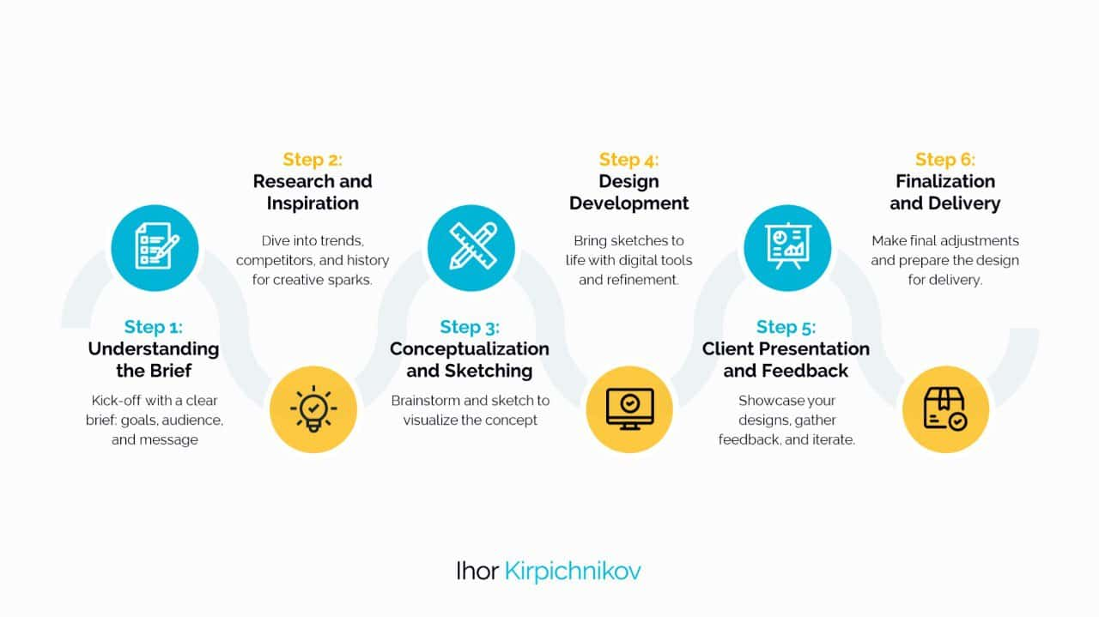
Figure 3 - Graphic Design Methodology (Kirpichnikov, 2025)

3D Modelling & Rendering
This next stage is a 6-step methodology slightly modified from two similar processes laid out by Nazanin Shahbazi of Pixune (Shahbazi, 2024), and GeeksForGeeks (GeeksForGeeks, 2025). These processes contain steps for other 3D sectors, such as games assets and animation, which are not relevant to this project.

Conceptualisation and Planning
This is where you determine what the model will be, and its purpose. It is best to look at references and other ideas to get a clearer vision of what to achieve. It is also recommended to draw a concept sketch to look at.
For example, if making a physical CD box for an album, determine how it should be shaped, and what it is being used for. Is it an example to show others or a digitised version of a real object? This is important to determine before starting the model.
Blockout
This step is where the modelling itself begins. In this step, use very simple shapes to create the big picture of the model. Stick with cubes, spheres, cylinders and cones for this step.
For example, when making an album box, block out basic thin cuboids. If the box is open, align the cuboids diagonally. You should prioritise the concept of the shape, rather than trying to form it into a more detailed object.

Modelling the Basic Shape
In this step, take the blocked out shapes created and refine the proportions and geometry.
For a geometric object like an album box, this step is simple. For example, take the inside of the cuboid and indent it so that objects could fit inside of it, much like a real box.

UV Mapping
UV Mapping is the process of taking a 3D model and turning it into a flat 2D object. This is done for the purpose of making sure textures line up with the model correctly.
In the example provided, this would be fairly straightforward. An album box would be made of squares and rectangles of various sizes, so very little work would need to be done.

Texturing
The next step is texturing, where a visual identity is given to the model. Various types of texture maps are applied to invoke colours, surface detail, reflections or shine, roughness, patterns, and simulated geometry.
In the album box example, this is the step where you make the box look more like a physical album rather than a generic cuboid shape.

Rendering
Rendering is the process of taking the finished model and putting it into a suitable scene, such as under virtual lights with a designated and modified virtual camera. This is done to put the model on display in a way that will appeal to a viewer, making the model itself look more professional and cleaner.
For the album box, this could be done by sitting the box partially open with a strong fill light, to show both the outside and inside of the box and its textures clearly.

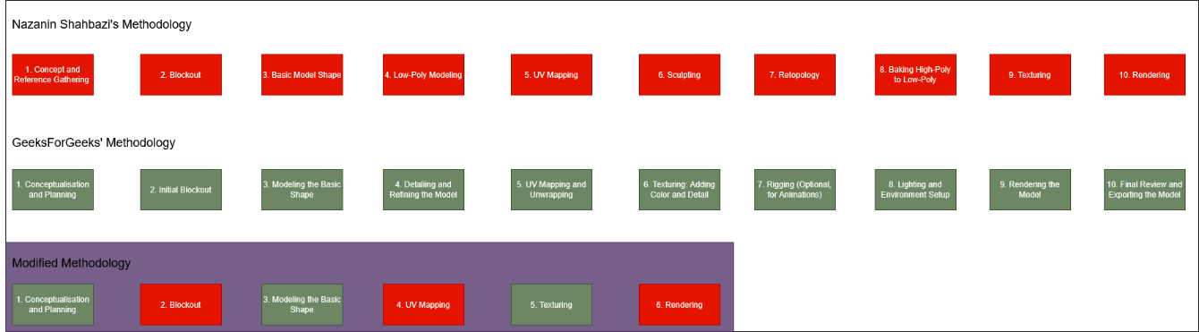
Figure 4 - 3D Modelling Methodology Diagram

Video Production & Rendering
This 4-step methodology used for Video Production and Rendering is based off of articles by Fiona Marsh of VMDigital (Marsh, 2021), and Jacob Trussell of Mountain.com (Trussell, 2025).

Pre-Planning
This step involves planning and deciding on what the video project will be. This is where the purpose of the video is established, what level of budget is available, whether or not a voice over is required, what the target audience is, what is to be conveyed, and where the video will be released and promoted.
For example, if making a promotional video for a new album, it’s best to include graphics showing the cover of the album and its design. A voice-over might not be necessary, instead a snippet of a track from the album could be used instead. In the case of this project, it’s presumed the budget will be low or even non-existent, and the target audience may be the general public or a particular niche of music listeners.

Pre-Production
For a video shot in person, this step would involve getting a cast together, organising shoots, creating a script, and deciding on a site. For a digital video, this step can instead involve gathering assets, making storyboards or animatics, and making a rudimentary version of the final video.
For the example of an album promotion, either method could be used, but for the purpose of sticking to a budget-friendly document, and to keep in line with the previous methodologies, it is presumed the project will be made entirely digitally. It’s best to have a 3D model and album cover design finished by this point to use for any promotional videos.

Production
This is where the video itself will be made. For real-life footage, this is the step where the footage itself is recorded and formatted for various screen sizes and social medias. For digitally created footage, this is where the scenes are made, usually in a 3D program and exported as an animated video.
For the album promotion example, a digitally created object and scene can be made in a chosen 3D Modelling and Rendering program, and created using basic animation and camera movements. At this stage of the process, nothing but video footage would be created.

Post-Production
This is where the real life and digital footages converge and follow the same process. This step involves taking recorded footage, whether filmed or generated, and putting it into a polished video. Adding text, music, colour grading, cutting and splicing footage, and polishing it into a finished project.
For the Album promotion example, this is where the created renders of the 3D objects would be put into a video editing and/or Digital Motion Graphics software and put together into a finished video.

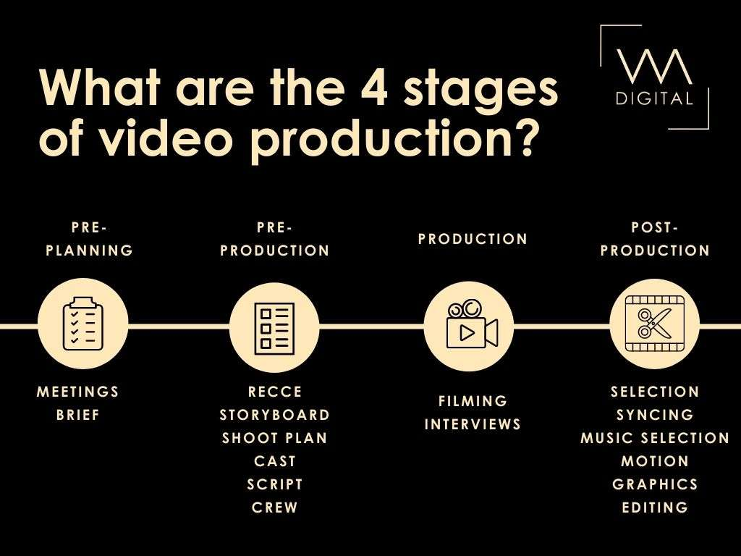
Figure 5 - Video Production Pipeline Diagram [vmdigital, 2021]

Chapter 6: Design

Album Box Design
The album box design can be quite varied. The most common type of physical music is a Jewel CD (Compact Disc) Case.
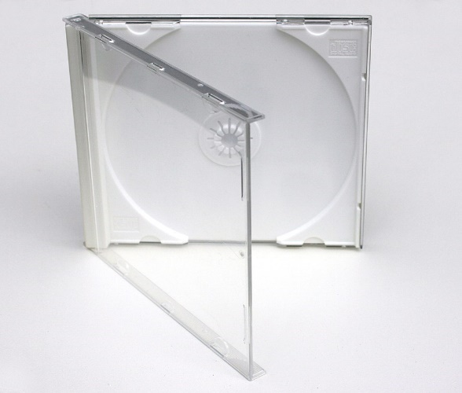
Figure 6 - Jewel CD Case [Ramón Vasconcellos, 2007]
There are more elaborate kinds of physical packaging. For example, Pop artists in South Korea often release physical music in a large box, with posters and other merchandise inside included with the CD (See Figure 6)
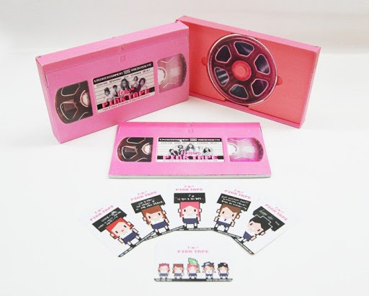
Figure 7 - Pink Tape by f(x) Album Box [Koreaboo, 2017]
There are also vinyl sleeves, which are not relevant to this project. This project will be going with the Album Box style of physical packaging. This allows for more variety and creativity with the promotional packaging.

CD Design
Music CDs usually have colourful and memorable designs on the front to make them recognisable. The back is always blank as it is required for the disc to be functional. This project aims to create an example design that matches the visual language of the album box created alongside it.
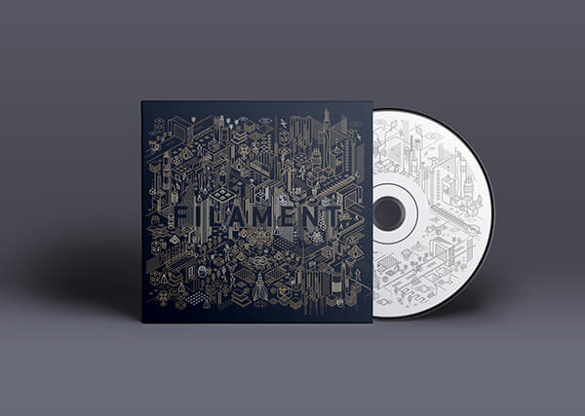
Figure 8 - Filament by Pragun Agarwal [Pragunagarwal.com, 2025]

T-Shirt Design
T-shirts are among the most common type of merchandise to create. T-shirt designs can be quite simple (such as a logo in the centre of the chest), or more complex. This project will make a somewhat simple example to use.
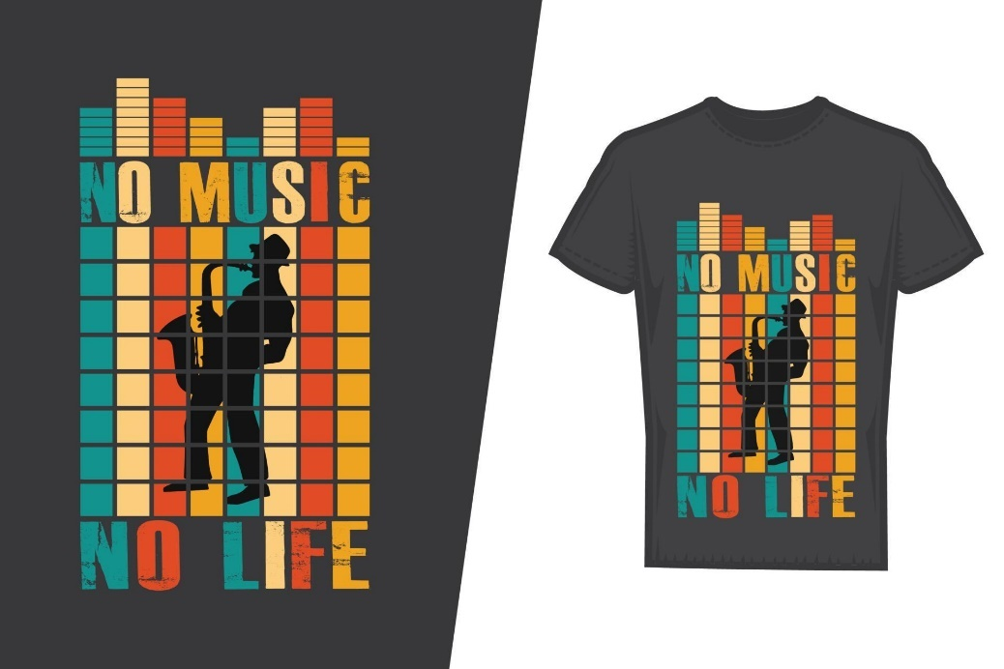
Figure 9 - Music T-Shirt Example [tasty design, 2025]

Poster Design
Posters are another common type of merchandise. Posters can be used to convey information, promote a product, or be used as a type of merchandise. This project will be making a merchandise poster for its example.

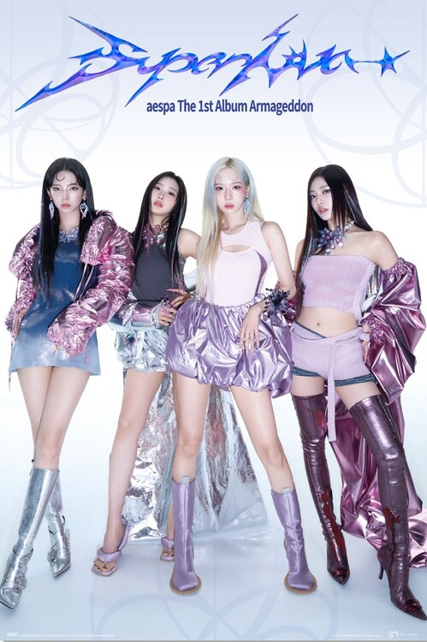
Figure 10 - Aespa Supernova Poster [Grupo Erik Editores S.L., 2025]

Promotional Video
A promotional video typically involves a short and flashy video intended to capture the attention of the viewer. It then displays information about the product or service being promoted. This project will be making a promotional video for a physical album release as an example.
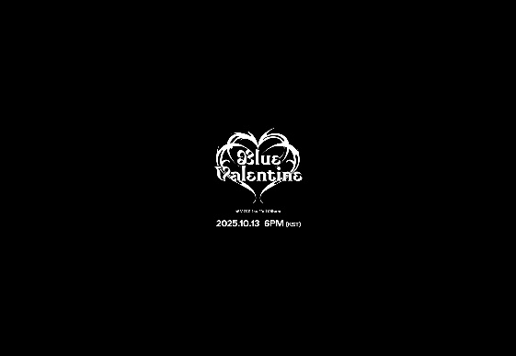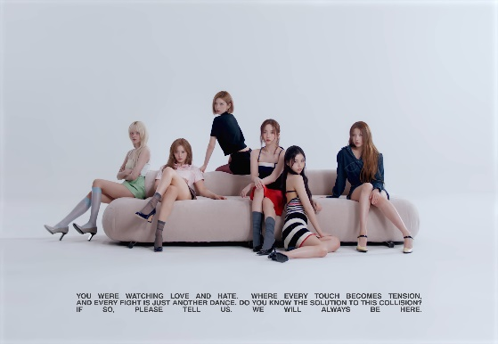
Figure 11 - NMIXX Promotional Video Example [JYP Entertainment, 2025]

Visualiser Video
A Visualiser is a type of music video, typically with a lower budget and smaller scope. These videos tend to not feature the artists and are sometimes created entirely using digital graphics. This project will be making a completely digital visualiser for one song as an example.
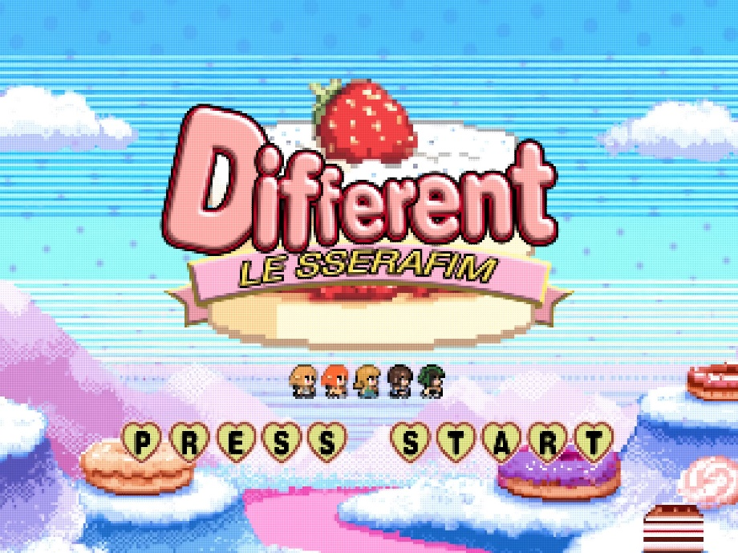
Figure 12 - LE SSERAFIM Visualiser Video Example [HYBE, 2025]

Chapter 7: Planning Schedule

Design and Development Schedule

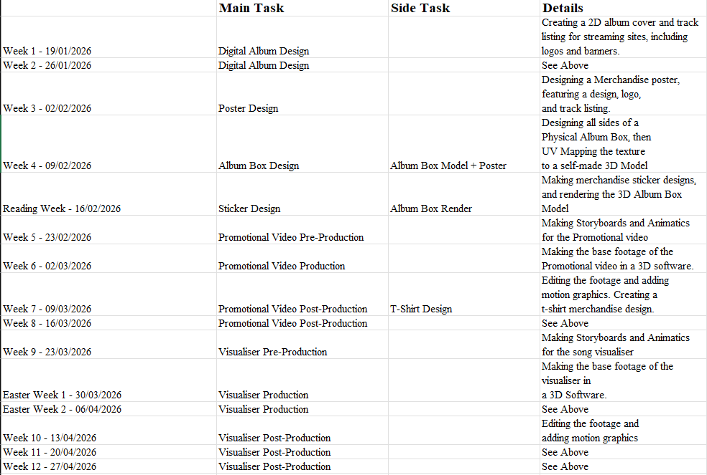
Figure 13 - Production Timeline example
(See Appendix for a Checklist version of this schedule)
A simple schedule of production for a typical University semester has been done up in Microsoft Excel. The 3D Modelling does not begin until after most of the Graphic Design has been done, as the graphic design assets are needed for the 3D Modelling. The same logic is used for the Video Production. More time has been allocated for the Video Production than the other aspects, as this aspect is more time-consuming and difficult.

Tracking Progress
Tracking Progress can be done through an Excel sheet much like this one, but it can also be done through a project management software such as Trello, which is more streamlined and granular.

Conclusion:
This document aims to give the reader a thorough explanation of the tool-kit provided. It gives instructions on how this tool-kit can be used, gives examples of software and the differences between them, shows examples of media to be created, and gives an example schedule to work with. A CD Design and the beginnings of a User Manual can be found in the appendix for further reading.

References

(Alphabetical order)
Balter, B. (2023). Cathedral vs Bazaar People Management. [online] Ben Balter. Available at: https://ben.balter.com/2023/12/08/cathedral-bazaar-management/ [Accessed 3 Nov. 2025].
Barker, J. (2021). This 6-Step Graphic Design Process Drives Results (Infographic). [online] Brafton. Available at: https://www.brafton.com/blog/graphics/graphic-design-process/. [Accessed 25 Nov. 25]
Blake, H. (2025). Cost-Benefit Analysis Proprietary Licensing Vs. Open Source Economics. [online] ResearchGate. Available at: https://www.researchgate.net/publication/392557896_Cost-Benefit_Analysis_Proprietary_Licensing_Vs_Open_Source_Economics. [Accessed 18th Nov 2025]

Jepsen, C.R., Berger, P. 2023. Kollage. Carly Rae Jepsen. The Loveliest Time. [Digital Audio]. United States: 604, Schoolboy, Interscope Records.
GeeksforGeeks (2025). 3D Modeling Process: A Step by Step Guide. [online] GeeksforGeeks. Available at: https://www.geeksforgeeks.org/blogs/3d-modeling-process-steps/. [Accessed 25 Nov. 25]
Grupo Erik Editores S.L. (2025). Europosters.ie [online] Available at: https://www.europosters.ie/posters/aespa-supernova-v184428 [Accessed 8 Dec. 25]
Hewson, A. (2025). Introducing the all-new Affinity: Professional design, now free for everyone. [online] Available at: https://www.canva.com/newsroom/news/all-new-affinity/. [Accessed 2 Dec. 25]
Hoffmann, M., Nagle, F. and Zhou, Y. (2024). The Value of Open Source Software. SSRN Electronic Journal. [online] https://doi.org/10.2139/ssrn.4693148. [Accessed 18th Nov 2025]
HYBE LABELS (2025). LE SSERAFIM (르세라핌) 'DIFFERENT (English ver.)' Official Visualizer. Available at: https://youtu.be/NezdSLx4O7w [Accessed 8 Dec. 25].
JYP Entertainment (2025). NMIXX(엔믹스) “Blue Valentine” Trailer: The Paradox of Love. Available at: https://youtu.be/QSvlQxjnQaQ [Accessed 8 Dec. 2025].
Kirpichnikov, I. (2024). 6-step Graphic Design Process: From Concept to Completion. [online] The best of AI and online business in one place. Available at: https://www.ikagency.com/graphic-design-typography/graphic-design-process/. [Accessed 25 Nov. 25]
Koreaboo. (2017). Koreaboo. [online] Available at: https://www.koreaboo.com/stories/11-kpop-albums-best-packaging/ [Accessed 2 Dec. 2025].
Marsh, F. (2021). What are the 4 stages of video production - VM Digital. [online] Available at: https://vmdigital.ie/stages-of-video-production/. [Accessed 2 Dec. 25]
Pragunagarwal.com. (2025). Filament — Pragun Agarwal — Portfolio. [online] Available at: https://pragunagarwal.com/Filament [Accessed 2 Dec. 25].
Sennett, R. (2008). The Craftsman. Penguin UK.
Shahbazi, N. (2024). 10 Main Steps in 3D Modeling Process. [online] Available at: https://pixune.com/blog/3d-modeling-process/. [Accessed 25 Nov. 25]
tasty design (2025). Music T-shirt design. Music t-shirt design vector. For t-shirt print and other uses. [online] Vecteezy. Available at: https://www.vecteezy.com/vector-art/11426982-music-t-shirt-design-music-t-shirt-design-vector-for-t-shirt-print-and-other-uses [Accessed 8 Dec. 2025].
Trussell, J. (2025). Video Production Process: Complete Guide for 2025 - QuickFrame. [online] QuickFrame. Available at: https://quickframe.mountain.com/blog/video-production-process/. [Accessed 2 Dec. 25]
University, D. of I.T.H., Ave, 400 S.O., South Orange, N. 07079 and (973) 275-2222 (n.d.). Adobe Creative Campus - Seton Hall University. [online] www.shu.edu. Available at: https://www.shu.edu/technology/adobe.html. [Accessed 18th Nov 2025]
Vasconcellos, R. (2007). Wikimedia. [online] Available at: https://commons.wikimedia.org/wiki/File:Jewel_Case_02.jpg [Accessed 8 Dec. 2025].
Wikipedia. (2021). Optical disc packaging. [online] Available at: https://en.wikipedia.org/wiki/Optical_disc_packaging. [Accessed 2 Dec. 25]

‌

‌

Appendices
Project Checklist:

